
DEPARTMENT OF

COMPUTER

Experiment 6
Student Name:Riya Kashyap UID: 25MCA20033
Branch: MCA-UIC Section/Group: 1
Semester: 2nd Date of Performance:24/2/2026
Subject Name: Technical Training Subject Code: 25CAP-652

- Aim: Learn how to create, query, and manage views in SQL to simplify database queries and provide a layer of abstraction for end-users..
- Objective
- Data Abstraction: To understand how to hide complex table joins and calculations behind a simple virtual table interface.
- Enhanced Security: To learn how to restrict user access to sensitive columns by providing views instead of direct table access.
- Query Simplification: To master the creation of views that pre-join multiple tables, making reporting easier for non-technical users.
- View Management: To understand the syntax for creating, altering, and dropping views, as well as the naming conventions required for efficient data access
- Theory:
A View is essentially a virtual table based on the result-set of an SQL statement. It does not contain data of its own but dynamically pulls data from the underlying "base tables".
- Simple Views: Created from a single table without any aggregate functions or grouping. These are often updatable.
- Complex Views: Created from multiple tables using JOINs, or including GROUP BY and aggregate functions. These provide a consolidated summary of the database.
- Security Layer: In enterprise environments, views are used to grant permissions on specific subsets of data. For example, a "SalaryView" might exclude the "Employee_SSN" or "Home_Address" columns for privacy.
- Benefits: They simplify the user experience, ensure data consistency across reports, and reduce the risk of accidental data modification by providing read-only abstractions.

- Procedure of the Practical:

Creation of Tables and Insertion of Data
-- Step0- Creation of Tables and Insertion of Data
CREATE TABLE departments (
dept_id SERIAL PRIMARY KEY,
dept_name VARCHAR(50)
);
CREATE TABLE employees (
emp_id SERIAL PRIMARY KEY,
emp_name VARCHAR(50),
salary NUMERIC,
status VARCHAR(20),
dept_id INT REFERENCES departments(dept_id)
);
INSERT INTO departments (dept_name)
VALUES ('HR'), ('IT'), ('Finance');
INSERT INTO employees (emp_name, salary, status, dept_id)
VALUES
('Riya', 50000, 'Active', 1),
('Aman', 60000, 'Inactive', 2),
('Karan', 70000, 'Active', 2),
('Neha', 55000, 'Active', 3);

Creating a Simple View (Data Filtering)
--Step 1- Creating a Simple View (Data Filtering)
CREATE VIEW ActiveEmployees AS
SELECT emp_id, emp_name, salary, dept_id
FROM employees
WHERE status = 'Active';
SELECT * FROM ActiveEmployees;

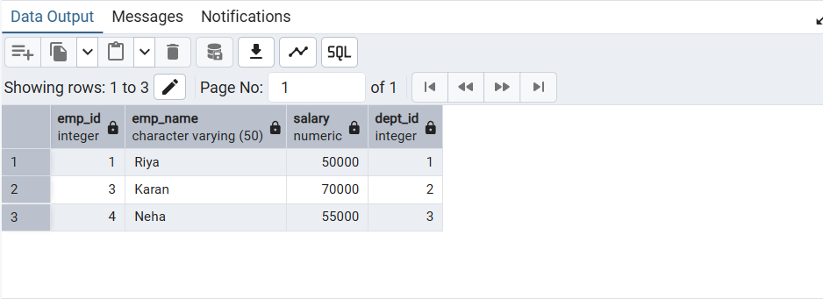

Creating a View for Joining Multiple Tables
--Step 2- Creating a View for Joining Multiple Tables
CREATE VIEW EmployeeDepartmentView AS
SELECT
e.emp_id,
e.emp_name,
e.salary,
d.dept_name
FROM employees e
JOIN departments d
ON e.dept_id = d.dept_id;
SELECT * FROM EmployeeDepartmentView;

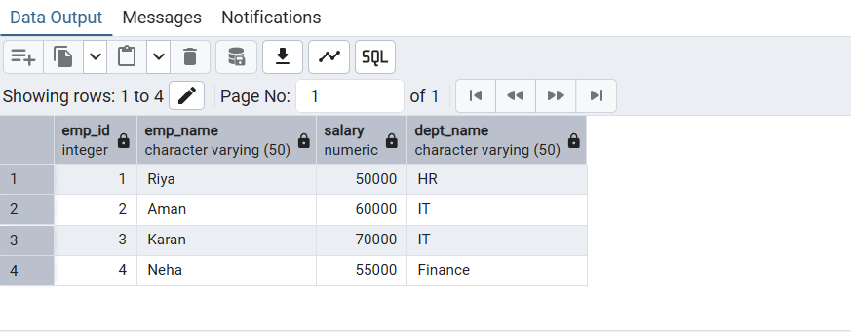
Creating an Advanced Summarization View
--Step 3-Creating an Advanced Summarization View
CREATE VIEW DepartmentStats AS
SELECT
d.dept_name,
COUNT(e.emp_id) AS total_employees,
AVG(e.salary) AS average_salary,
SUM(e.salary) AS total_salary
FROM departments d
LEFT JOIN employees e
ON d.dept_id = e.dept_id
GROUP BY d.dept_name;
SELECT * FROM DepartmentStats;

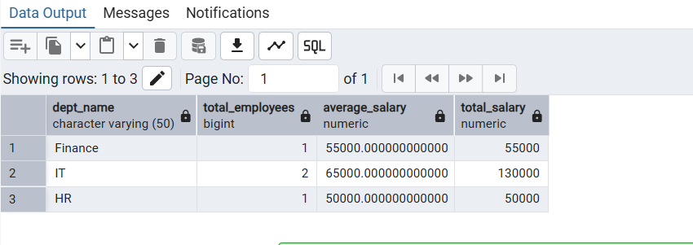

- Learning Outcome:
- Abstraction Proficiency: Students will be able to create and query views to simplify efficient data access and abstraction.
- Security Implementation: Students will understand how to use views for data masking and providing restricted access to sensitive information.
- Syntactic Accuracy: Students will demonstrate the correct syntax for creating and querying views, ensuring logical clarity in naming conventions.
- Real-world Application: Students will be able to design views for practical domains like Library Management Systems or Payroll Systems to demonstrate functionality.

